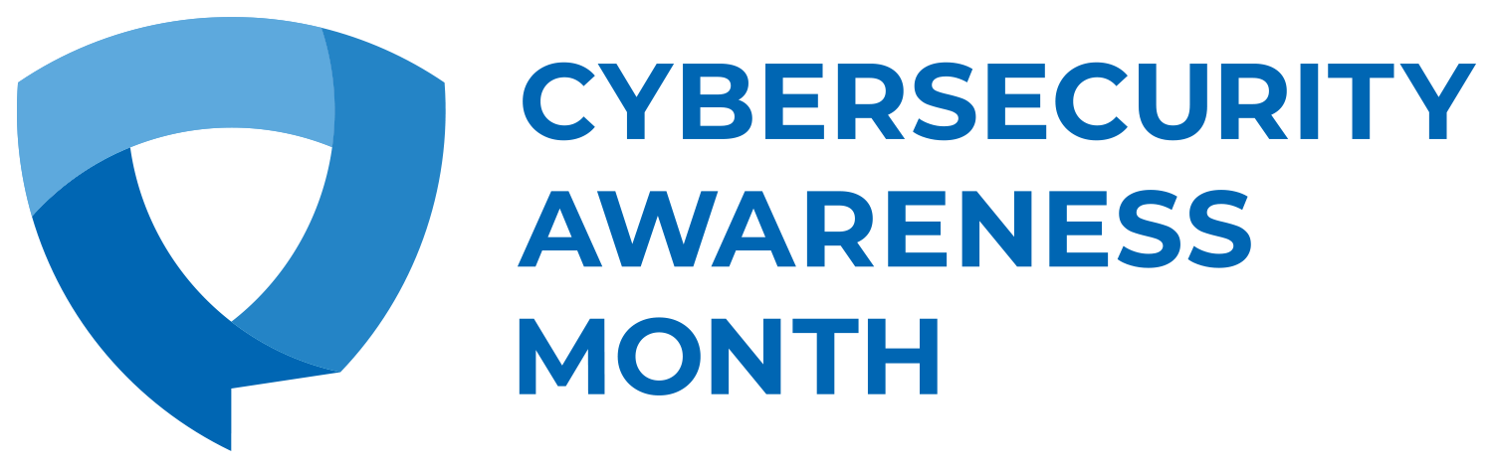

**Email Template for Distribution to Employees**

**Suggested Subject Line:** It’s easy to stay safe online - A Message from **[leadership name and/or title]**

October is Cybersecurity Awareness Month, a global effort to help everyone stay safe and protected when using technology whenever and however you connect. **[Company/Organization]** is proud to be a Champion and support this online safety and education initiative this October.

This month is all about taking action! All month long, we are promoting these key behaviors to encourage every employee to take control of their online lives. There are all kinds of ways to stay safe and secure online but even just practicing these cybersecurity basics can make a huge difference:

**[Use the behaviors below or customize them to fit the needs of your organization]**

1. Enable Multi-Factor Authentication
2. Use Strong Passwords and a Password Manager
3. Update Your Software
4. Recognize and Report Phishing

The cybersecurity and digital privacy of our employees and customers is important to **[Company/Organization].** Throughout the month of October, **[Company/Organization]** will **[insert summary of Company/Organization’s initiatives]**.

**[Consider adding a calendar of events]**

We want to help you, your family, friends, and our community stay safe all year long, too. We encourage you to [sign up as an individual Cybersecurity Awareness Month Champion.](https://staysafeonline.org/cybersecurity-awareness-month/champions/) After signing up, you’ll receive a toolkit of free resources, including simple steps you can take to #BeCyberSmart.

Cybersecurity Awareness Month is co-led by the National Cybersecurity Alliance and the Cybersecurity and Infrastructure Agency (CISA). For more information about ways to keep you and your family safe online visit <https://staysafeonline.org/cybersecurity-awareness-month/> and <https://www.cisa.gov/cybersecurity-awareness-month>